**Name:Yashodha R Naik**

**USN: 1NT20IS416**

**C section**

> use yashodha

switched to db yashodha

> db.collection.insertOne({name:"yashodha",usn:"1NT20IS416",sec:"c",})

{

"acknowledged" : true,

"insertedId" : ObjectId("6246e97bfab5dabe51f97d4c")

}

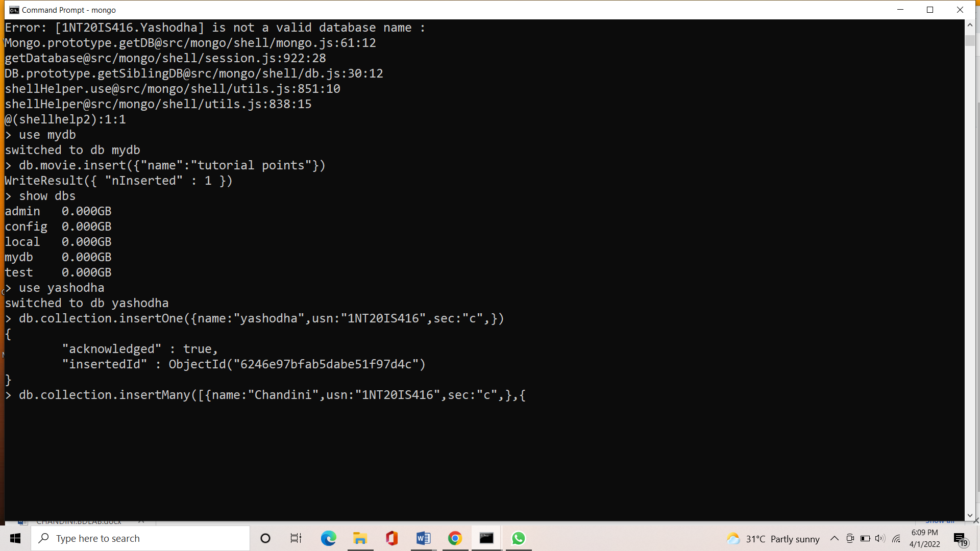

> db.collection.insertMany([{name:"Chandini",usn:"1NT20IS416",sec:"c",},{name:"Annapurna",usn:"1NT20IS416",sec:"c"}])

{

"acknowledged" : true,

"insertedIds" : [

ObjectId("6246f3befab5dabe51f97d4d"),

ObjectId("6246f3befab5dabe51f97d4e")

]

}

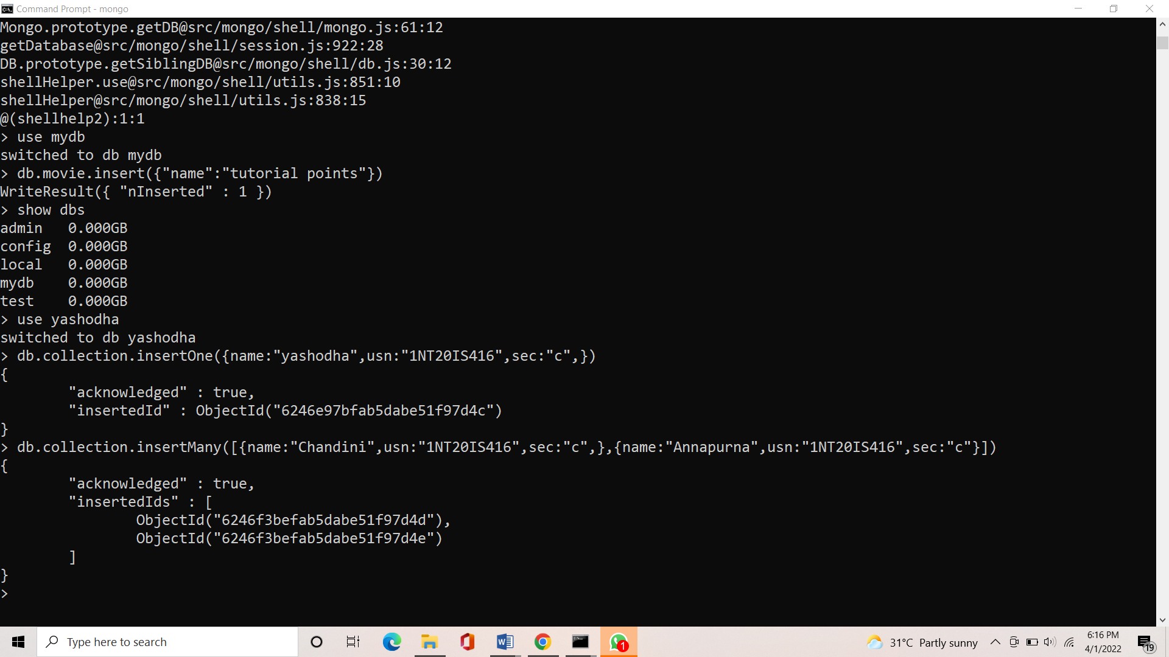

> db.collection.find({})

{ "_id" : ObjectId("6246e97bfab5dabe51f97d4c"), "name" : "yashodha", "usn" : "1NT20IS416", "sec" : "c" }

{ "_id" : ObjectId("6246f3befab5dabe51f97d4d"), "name" : "Chandini", "usn" : "1NT20IS416", "sec" : "c" }

{ "_id" : ObjectId("6246f3befab5dabe51f97d4e"), "name" : "Annapurna", "usn" : "1NT20IS416", "sec" : "c" }

>

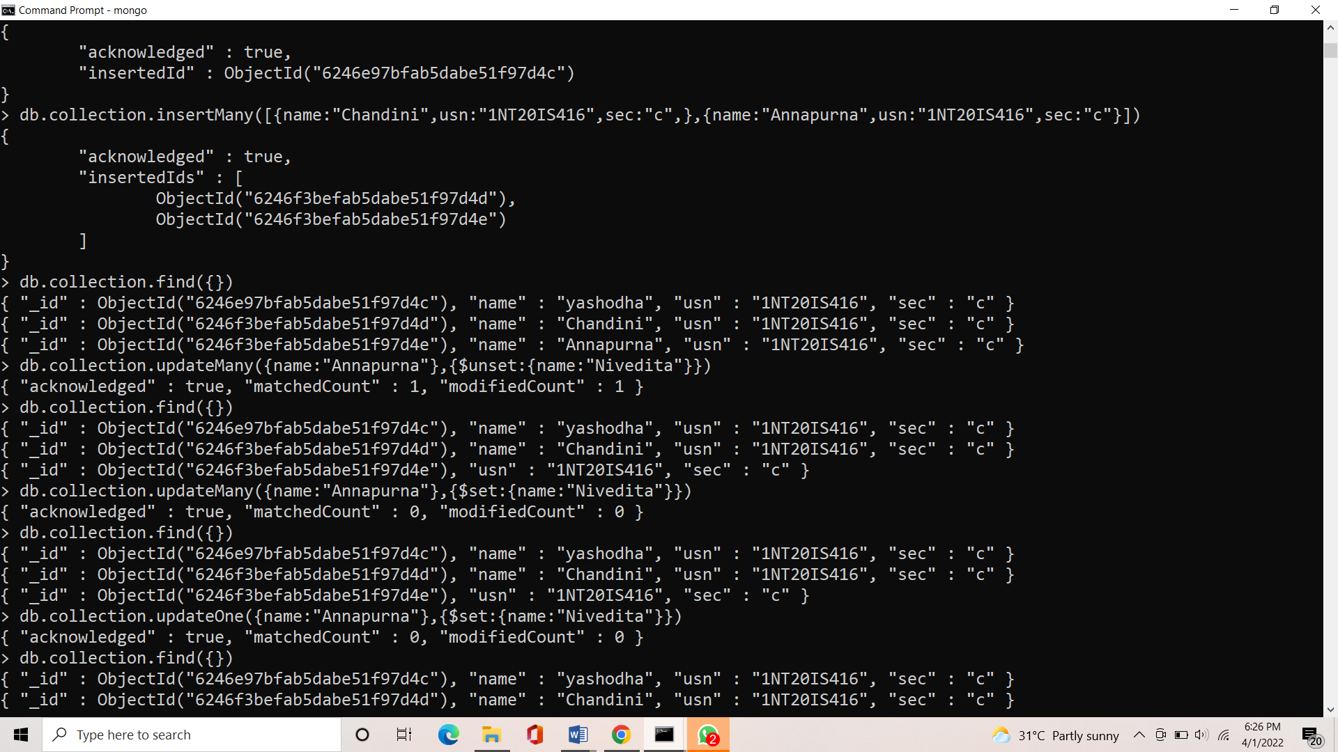

**UPDATE OPERATION ON SET:**

db.collection.updateOne({name:"Annapurna"},{$set:{name:"Nivedita"}})

{ "acknowledged" : true, "matchedCount" : 0, "modifiedCount" : 0 }

> db.collection.find({})

{ "_id" : ObjectId("6246e97bfab5dabe51f97d4c"), "name" : "yashodha", "usn" : "1NT20IS416", "sec" : "c" }

{ "_id" : ObjectId("6246f3befab5dabe51f97d4d"), "name" : "Chandini", "usn" : "1NT20IS416", "sec" : "c" }

{ "_id" : ObjectId("6246f3befab5dabe51f97d4e"), "usn" : "1NT20IS416", "sec" : "c" }

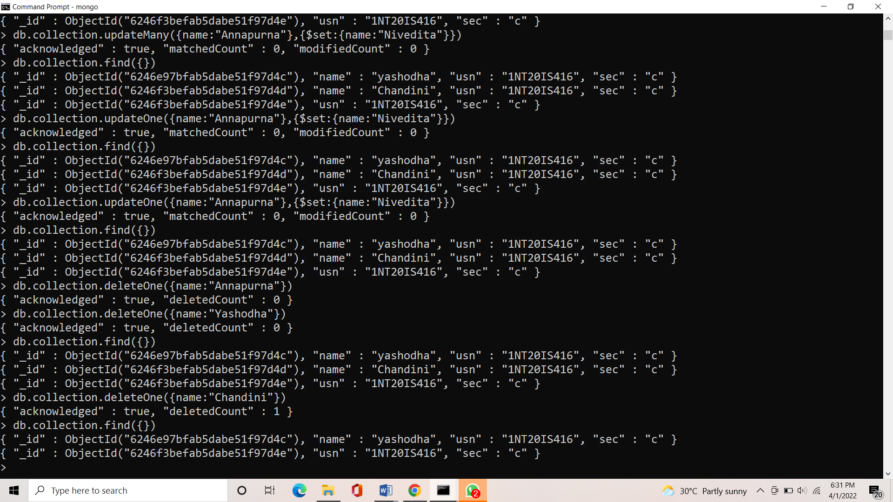

**DELETE OPERATION:**

db.collection.deleteOne({name:"Chandini"})

{ "acknowledged" : true, "deletedCount" : 1 }

> db.collection.find({})

{ "_id" : ObjectId("6246e97bfab5dabe51f97d4c"), "name" : "yashodha", "usn" : "1NT20IS416", "sec" : "c" }

{ "_id" : ObjectId("6246f3befab5dabe51f97d4e"), "usn" : "1NT20IS416", "sec" : "c" }



db.collection.insertOne({name:"Annapurna",usn:"1NT20IS416",sec:"c",})

{

"acknowledged" : true,

"insertedId" : ObjectId("6246f92afab5dabe51f97d4f")

}

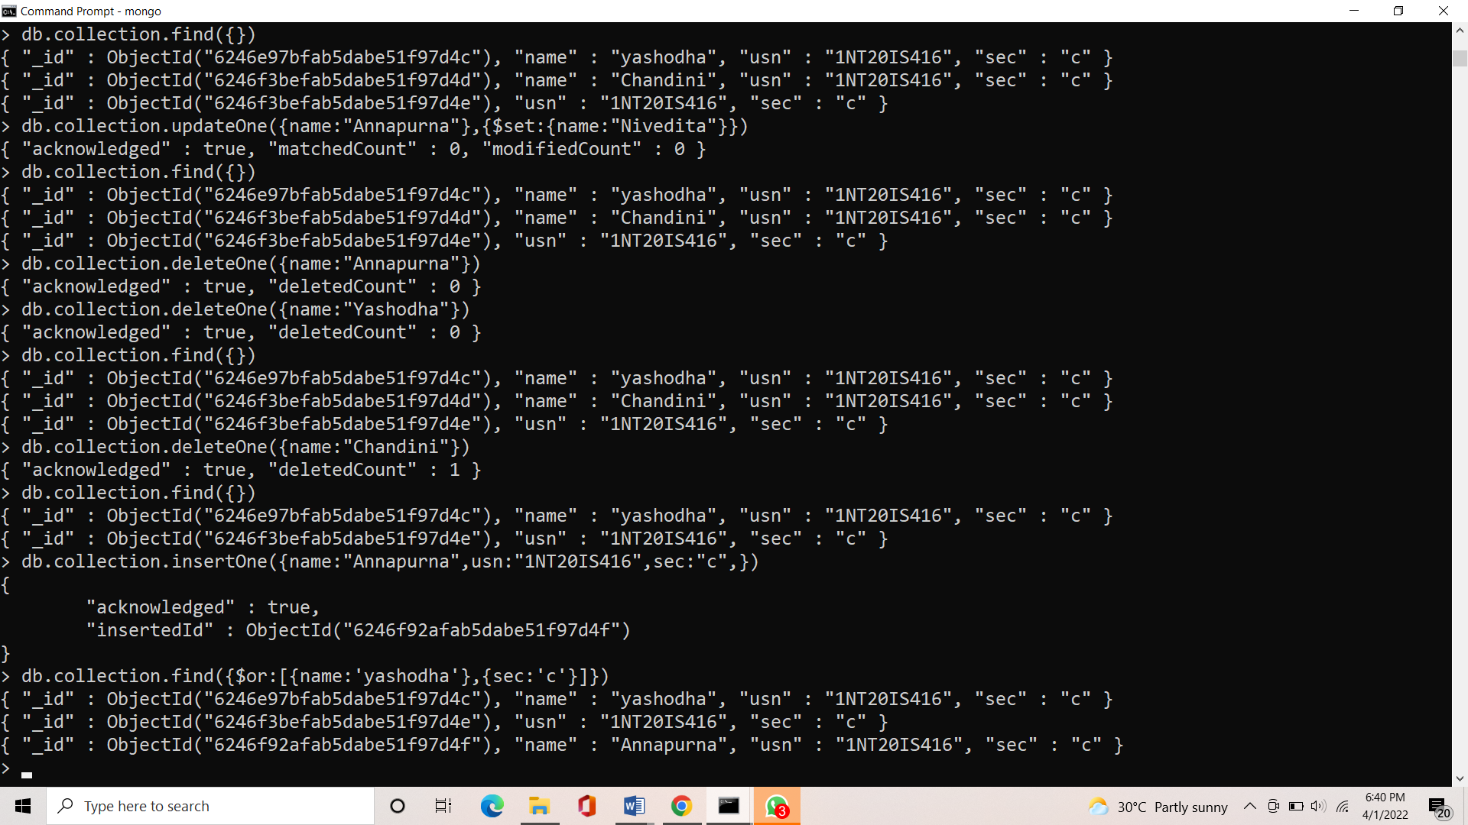

**OR OPERATION:**

> db.collection.find({$or:[{name:'yashodha'},{sec:'c'}]})

{ "_id" : ObjectId("6246e97bfab5dabe51f97d4c"), "name" : "yashodha", "usn" : "1NT20IS416", "sec" : "c" }

{ "_id" : ObjectId("6246f3befab5dabe51f97d4e"), "usn" : "1NT20IS416", "sec" : "c" }

{ "_id" : ObjectId("6246f92afab5dabe51f97d4f"), "name" : "Annapurna", "usn" : "1NT20IS416", "sec" : "c" }

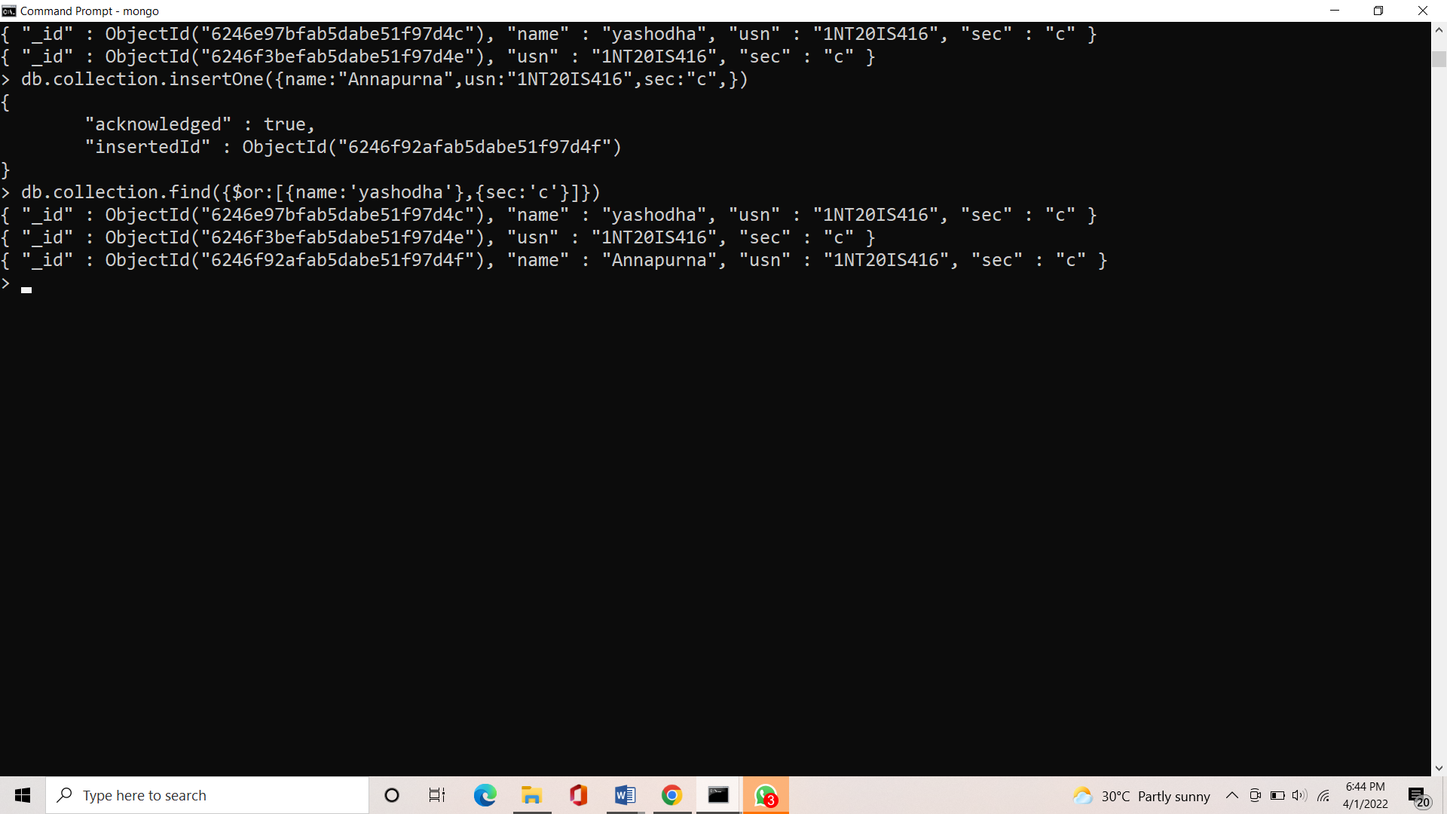

db.collection.find({$and:[{name:'yashodha'},{sec:'c'}]})

{ "_id" : ObjectId("6246e97bfab5dabe51f97d4c"), "name" : "yashodha", "usn" : "1NT20IS416", "sec" : "c" }

